**Assessment of the efficiency and effectiveness of Antenatal and Delivery Services at Oyigbo Comprehensive Health Centre: A one-year Retrospective review**

Table 1.1: Sociodemographic Data

|  |  |  |
| --- | --- | --- |
| **Variable** | **Frequency (n=498)** | **Percent** |
| **Age Group (n=488)** |  |  |
| 15 - 19 | 11 | 2.3 |
| 20 -24 | 94 | 19.3 |
| 25 - 29 | 148 | 30.3 |
| 30 - 34 | 154 | 31.6 |
| 35 - 39 | 62 | 12.7 |
| 40 - 44 | 17 | 3.5 |
| 45 - 49 | 2 | 0.4 |
| Mean ± SD | 29.30 ± 5.43 |  |
| **Literacy Status (n = 458)** |  |  |
| Literate | 447 | 97.6 |
| Non literate | 11 | 2.4 |
| **Employment Status (n = 498)** |  |  |
| Employed | 230 | 46.2 |
| Unemployed | 268 | 53.8 |
| **HIV Status (n = 474)** |  |  |
| Positive | 13 | 2.7 |
| Negative | 461 | 97.3 |
| **VDRL Test (n = 374)** |  |  |
| Positive | 8 | 2.1 |
| Negative | 366 | 97.9 |
| **Hepatitis B (n = 375)** |  |  |
| Positive | 8 | 2.1 |
| Negative | 367 | 97.9 |

Table 1.1 presents the sociodemographic characteristics of the study participants (n = 498). The majority of the respondents were aged between 25–34 years (61.9%), with a mean age of 29.30 ± 5.43 years. Literacy levels were high, with 97.6% of participants identified as literate. Employment status showed that 46.2% were employed, while 53.8% were unemployed. Regarding health status, HIV prevalence was 2.7%, while VDRL (syphilis) and Hepatitis B positivity rates were 2.1% each. These findings provide insight into the demographic and health profile of the study population.

**Figure 1.1**

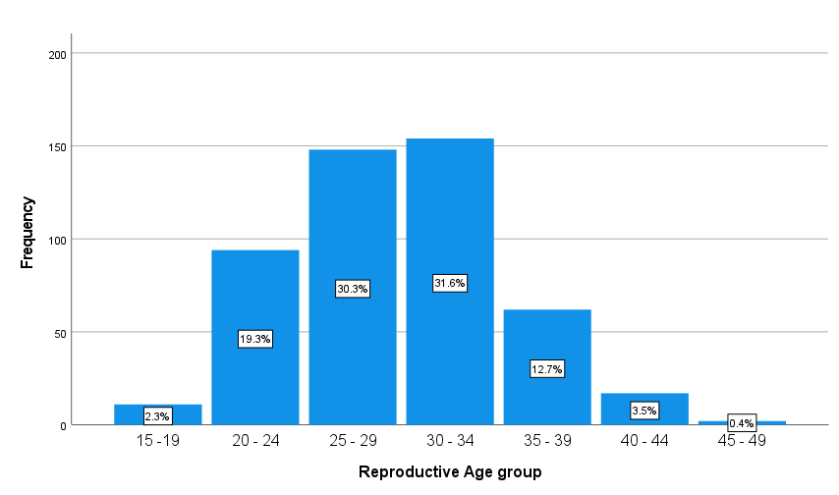

Figure 1.1 illustrates the distribution of study participants by reproductive age group. The majority of respondents fall within the 25–34 age range, with 30.3% aged 25–29 years and 31.6% aged 30–34 years. The 20–24 age group accounts for 19.3% of the sample, while those aged 35–39 make up 12.7%. The least represented groups are 15–19 years (2.3%), 40–44 years (3.5%), and 45–49 years (0.4%). This distribution highlights that most participants are in their prime reproductive years, with a gradual decline in frequency among older age groups.

**Figure 1.2**

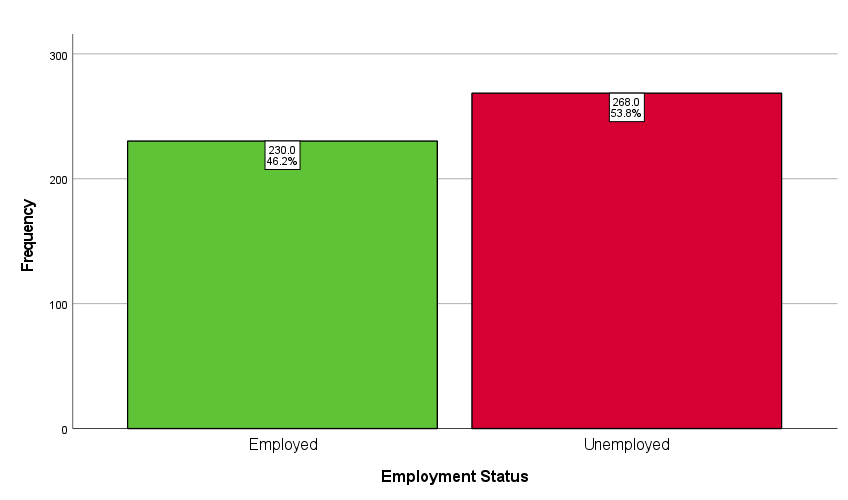

Figure 1.2 depicts the employment status of the study participants. Out of the total respondents, 46.2% (230 individuals) are employed, while 53.8% (268 individuals) are unemployed. The distribution shows a slightly higher proportion of unemployed participants compared to those who are employed.

**Figure 1.3**

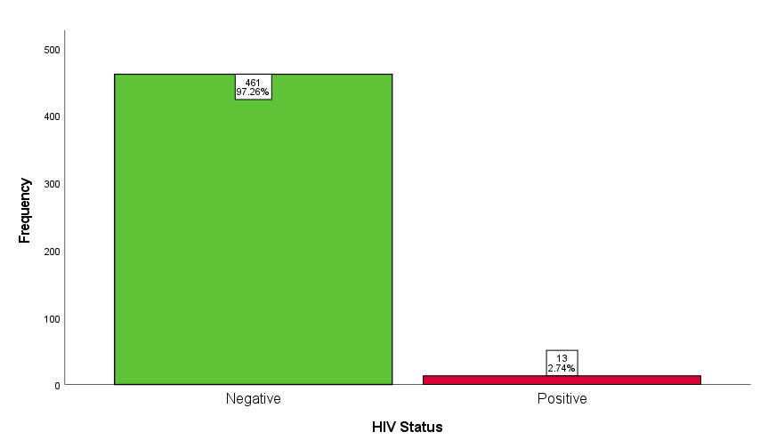

Figure 1.3 presents the HIV status of the study participants. The majority of respondents (97.3%) tested negative for HIV, while 2.7% tested positive. This low prevalence of HIV among the study population suggests a relatively low burden of the disease.

**What was the total number of Antenatal patients recorded?**

Total Number of Antenatal Visits recorded in 2024 was 498.

**What was the total number of Deliveries recorded in the time period?**

Table 1.2

|  |  |  |
| --- | --- | --- |
| **Variable** | **Frequency** | **Percent** |
| **Facility Admissions (n=161)** |  |  |
| Delivered in Facility | 149 | 92.5 |
| Referred to other facilities | 12 | 7.5 |

Table 1.2 summarizes the facility admissions of the study participants. Out of 161 cases, 92.5% (149 individuals) successfully delivered within the facility, while 7.5% (12 individuals) were referred to other healthcare facilities for further care.

**Figure 1.4**

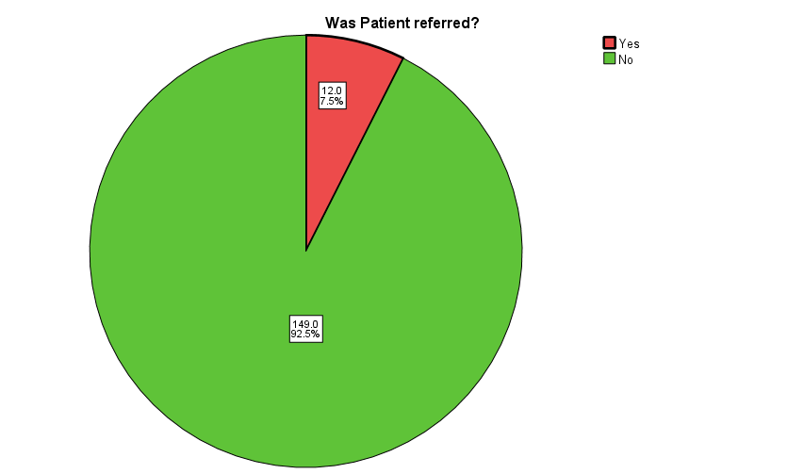

**What proportion of women registered for Antenatal ultimately delivered at the facility?**

Table 1.3

|  |  |  |
| --- | --- | --- |
| **Variable** | **Frequency** | **Percent** |
| **Delivery (n=464)** |  |  |
| CHC Oyigbo | 136 | 29.3 |
| Other Facilities | 328 | 70.7 |

Table 1.3 presents data on the place of delivery among 464 participants. A total of 29.3% (136 individuals) delivered at CHC Oyigbo, while the majority, 70.7% (328 individuals), gave birth in other healthcare facilities. This distribution suggests that a significant proportion of deliveries occurred outside CHC Oyigbo, indicating possible preferences, limitations in accessing the facility or knowledge gap.

**Figure 1.5**

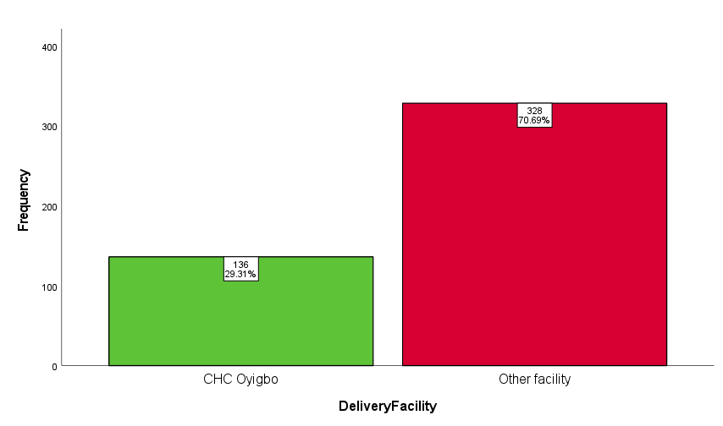

**Factors that are associated with Delivery Place**

Table 1.4

|  |  |  |  |  |
| --- | --- | --- | --- | --- |
| **Variables** | **Place of Delivery** | | **X2** | **P value* (α=0.05)** |
|  | **CHC (n=136)** | **Others (n=319)** |  |  |
| **Age** |  |  |  |  |
| 15 - 19 | 3 (27.3) | 8 (72.7) |  |  |
| 20 -24 | 23 (27.4) | 61 (72.6) |  |  |
| 25 - 29 | 48 (34.3) | 92 (65.7) |  |  |
| 30 - 34 | 42 (29.4) | 101 (70.6) | 10.855 | 0.093 |
| 35 - 39 | 11(18.3) | 49 (81.7) |  |  |
| 40 - 44 | 8 (50.0) | 8 (50.0) |  |  |
| 45 - 49 | 1 (100) | 0 (0.0) |  |  |
| **Employment Status** |  |  |  |  |
| Employed | 61 (28.8) | 151(71.2) | 0.54 | 0.816 |
| Unemployed | 75 (29.8) | 177 (70.2) |  |  |
| **Literacy Level** |  |  |  |  |
| Literate | 127 (30.4) | 291 (69.6) | 0.50 | 0.479 |
| Non-Literate | 2 (20.0) | 8 (80.0) |  |  |
| **Husband’s Occupation** |  |  |  |  |
| Lower pay | 41 (30.4) | 94 (69.6) |  |  |
| Medium Pay | 68 (28.2) | 173 (71.8) | 0.280 | 0.870 |
| Higher Pay | 26 (30.6) | 59 (69.4) |  |  |
| **HIV Status** |  |  |  |  |
| Positive | 3 (25.0) | 9 (75.0) | 0.127 | 0.721 |
| Negative | 128 (29.8) | 302 (70.2) |  |  |
| **Hepatitis B Status** |  |  |  |  |
| Positive | 6 (75.0) | 2 (25.0) | 8.558 | **0.003\*** |
| Negative | 94 (27.6) | 246 (72.4) |  |  |
| **Parity** |  |  |  |  |
| 0 -2 | 104 (27.8) | 270 (72.2) |  |  |
| 3 -5 | 29 (36.7) | 50 (63.3) | 4.470 | 0.107 |
| 6 -8 | 2 (66.6) | 1 (33.3) |  |  |
| **Gravidity** |  |  |  |  |
| 1 – 3 | 95 (28.4) | 239 (71.6) |  |  |
| 4 – 6 | 35 (37.2) | 59 (62.8) | 4.702 | 0.095 |
| 7 – 9 | 3 (60.0) | 2 (40.0) |  |  |
| **Antenatal Coverage** |  |  |  |  |
| 1 – 3 | 5 (3.6) | 134 (96.4) |  |  |
| 4 – 6 | 70 (34.1) | 135 (65.9) | 79.547 | **<0.001\*** |
| 7 – 9 | 48 (55.8) | 38 (44.2) |  |  |
| 10 – 12 | 7 (53.8) | 6 (46.2) |  |  |

* p-value less than 0.05 is significant

Table 1.4 shows that there is no statistical significance between Age, Employment status, Literacy, Husbands relative earning, HIV status, Parity and Gravidity with place of delivery as they all have p-values > 0.05. There is significant association between Hepatitis B status and delivery place with those with the disease more likely to deliver in CHC Oyigbo than not. Also, there is a significant association between Antenatal coverage and delivery place with women with more antenatal visits being more likely to deliver at CHC Oyigbo.

**Figure 1.5**

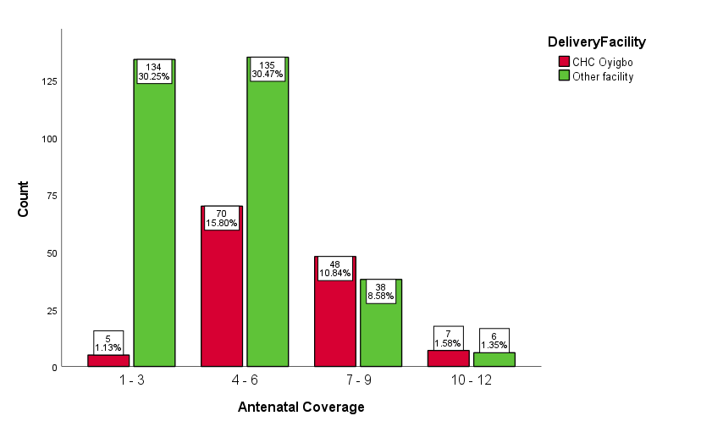

Figure 1.5 is a clustered bar chart displaying the distribution of antenatal coverage among women based on their place of delivery, categorized as CHC Oyigbo (red) and other facilities (green). The x-axis represents the number of antenatal visits grouped into four categories: 1–3, 4–6, 7–9, and 10–12, while the y-axis shows the count of women in each category. The highest proportions are seen in the 1–3 and 4–6 visit categories, with more women delivering at other facilities compared to CHC Oyigbo. The number of women decreases as antenatal visits increase, with both groups having the lowest counts in the 10–12 visit category. The chart indicates that women who had fewer antenatal visits were more likely to deliver at other facilities.

**Is there any difference in birth weight between booked and unbooked patient delivery?**

Table 1.5

|  |  |
| --- | --- |
| **Birth Weight Statistics** | |
| Mean | 3.3428 |
| Standard Deviation | 0.48104 |
| Minimum | 1.80 |
| Maximum | 4.90 |

Table 1.6

|  |  |  |  |  |
| --- | --- | --- | --- | --- |
| **Group (n)** | **Mean** | **Std. Deviation** | **t-value** | **P-value** |
| Booked (100) | 3.256 | 0.4082 |  |  |
| Unbooked (5) | 3.420 | 0.6221 | -0.855 | 0.395 |

The independent samples t-test showed no significant difference in birth weight between booked (M = 3.2561, SD = 0.40819) and unbooked (M = 3.4200, SD = 0.62209) deliveries, t(103) = -0.855, p = 0.395.

**What is the facility Antenatal Completion Rate ?**

Table 1.7

|  |  |  |
| --- | --- | --- |
| **Variable** | **Frequency** | **Percent** |
| **ANC Visits (n=498)** |  |  |
| Less than 4 visits | 154 | 30.9 |
| >= 4 visits | 344 | 69.1 |

Completion Rate = Completed Visits/Total * 100

Completion Rate = 344/498*100 = **69.1%**

**What factors are associated with birth outcome?**

Table 1.8

|  |  |  |  |  |
| --- | --- | --- | --- | --- |
| **Variables** | **Delivery Outcome** | | **X2** | **P value* (α=0.05)** |
|  | **Live birth (n=109)** | **Still Birth (n=2)** |  |  |
| **Booking Trimester** |  |  |  |  |
| First | 20 (100) | 0 (0) | 2.026 | 0.363 |
| Second | 72 (98.6) | 1 (1.4) |  |  |
| Third | 16 (94.1) | 1 (5.9) |  |  |
| **Maternal Weight at booking** |  |  |  |  |
| Greater than 90 | 10(83.3) | 2 (16.7) | 16.803 | **<0.001\*** |
| Less than Or equal to 90 | 99(100) | 0 (0.0) |  |  |

The table examines factors associated with birth outcomes, focusing on booking trimester and maternal weight. Birth outcomes by trimester show no significant association (p = 0.363), with most live births occurring regardless of booking time. However, maternal weight at booking shows a significant association (p < 0.001), as 16.7% of women weighing over 90 kg had stillbirths, while all those weighing ≤90 kg had live births.